Powell Industries Oracle Primavera Cloud Data Replication to Snowflake and KPI Cloud Analytics for EBS Projects Out of the Box Deployment

Founded in 1947,[[1]](https://en.wikipedia.org/wiki/Powell_Industries#cite_note-1) Powell Industries Inc. ([Nasdaq](https://en.wikipedia.org/wiki/Nasdaq): [POWL](https://www.nasdaq.com/market-activity/stocks/powl)) is a manufacturer of Integrated/Packaged Solutions and Electrical Equipment to monitor and control the distribution of electrical power in commercial and industrial markets, with headquarters in [Houston, Texas](https://en.wikipedia.org/wiki/Houston,_Texas). Products include Power Control Rooms, E-Houses, ANSI/IEC [switchgear](https://en.wikipedia.org/wiki/Switchgear), MV and LV motor Control, LV switchgear, Bus Duct, Utility Transfer Switches, DC switchgear, bus duct, field services, and Power Management and Control Systems.

Our client aimed to achieve parallel data integration from Oracle Primavera Cloud and Oracle EBS to Snowflake. Their goal was to streamline data integration for the Project analytics module for different projects enabling control and monitoring. They sought to harness Snowflake with Azure Data Factory to orchestrate data pipelines for project management.

**Team**: ETL Development Team

**Customer Location:** United States

**Technologies used in Project / Tech Stack**: Snowflake, Azure Data Factory, Oracle EBS and Primavera, Azure BLOB Storage, Azure DevOps.

**Duration:** 3 Months

**KPI Folks:** 5 resources

**Completion:** Completed.

**Brief:** Our main task is to bring data from source like Oracle Primavera REST API, Oracle EBS to snowflake and deploy KPI cloud project analytics DataMart.

Below is list of tasks involved.

* 1. Build a framework with the help of ADF ETL pipeline to extract data from Oracle Primavera Cloud Data Service API as per architecture shown in Figure 2
  2. Develop Azure Data Factory Pipelines to extract and load data into Snowflake.
  3. Modify Existing Powell ETL Code as Starting Point to write ETL code in SQL to load data to Data Warehouse
  4. Apply transformations in between to flatten hierarchical JSON data into structured format and load data into the Snowflake.
  5. KPI Cloud Analytics Prebuilt ETL and Prebuilt data models for Oracle EBS Projects to be deployed as per architecture shown in Figure 1
  6. Mostly we have used ADF for this purpose and build pipelines for data integration from Oracle system to snowflake data warehouse.
  7. We have designed ADF Extract & Load pipeline in dynamic way to adopt changes done into source system for data or metadata with the help of snowflake store procedure and metadata tables.

The architecture of the solution for KPI Cloud Analytics for Oracle EBS Projects Out of the Box Deployment is as shown in Figure 1.

Data replication using Oracle Primavera Cloud Data Service API to ingest Primavera Cloud Project Management Data to Snowflake is as shown in Figure 2

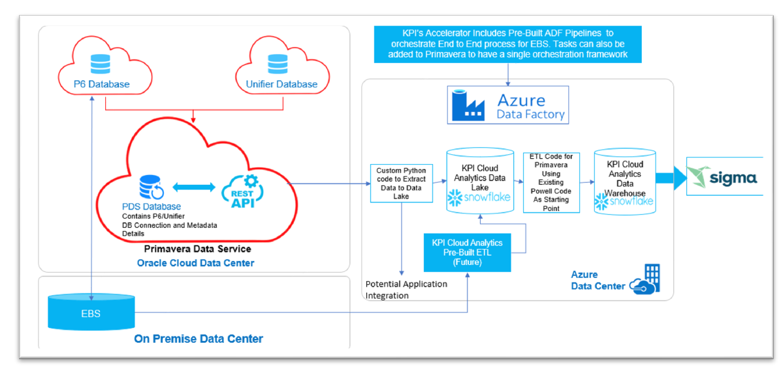

**ABOUT KPI PARTNERS:**

KPI Partners is a global strategic partner specializing in Analytics and Digital Transformation solutions, is at the forefront of driving innovation in data analytics, AI/ML/LLM, and digital transformation across diverse industries. Recognized by Gartner, KPI Partners has a

remarkable track record of serving over 300+ delighted clients, delivering excellence through 1000+ successful projects. Our global team of over 600 consultants strategically spans across North America, Latin America, and India, ensuring a comprehensive reach to meet your business needs.

If you’re on a journey of growth and innovation, and you’re seeking a global partner in Data Analytics, AI, and Digital Transformation, let’s connect to explore how KPI Partners can

elevate your business to new heights.

To learn more about our offerings, visit <https://www.kpipartners.com/> or reach out to us at [info@kpipartners.com](mailto:info@kpipartners.com).